URL :

<https://www.youtube.com/watch?v=8_r28jJ6AM&list=PLdpzxOOAlwvLNOxX0RfndiYSt1Le9azze&index=22>

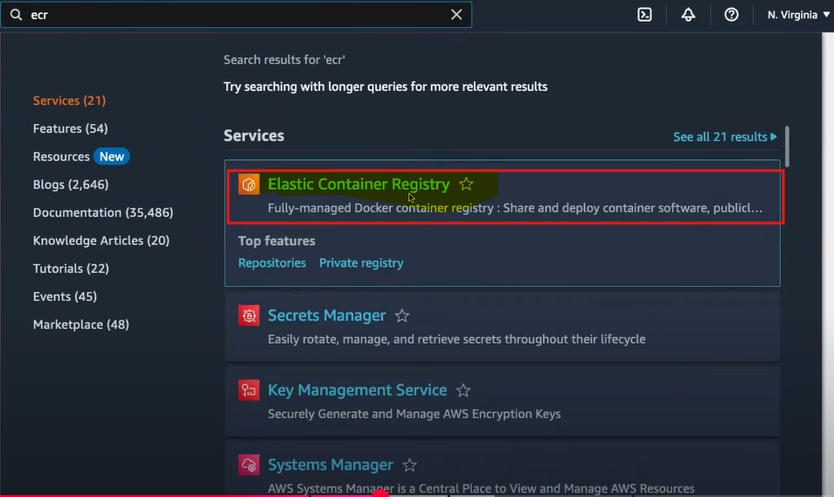

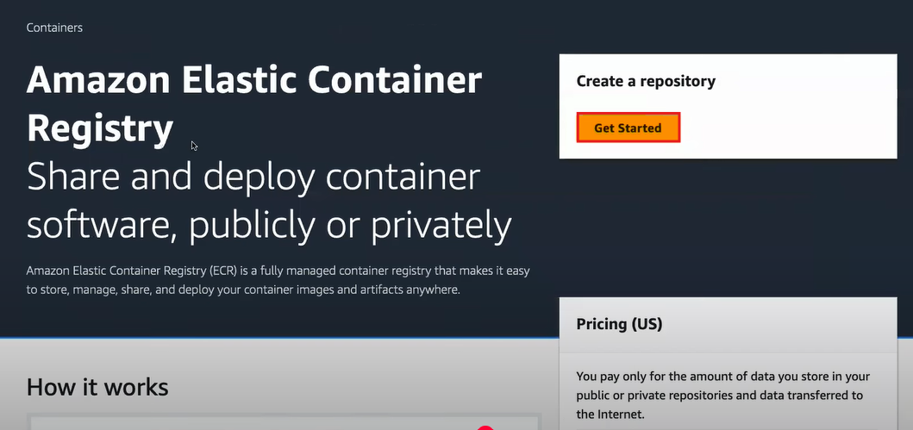

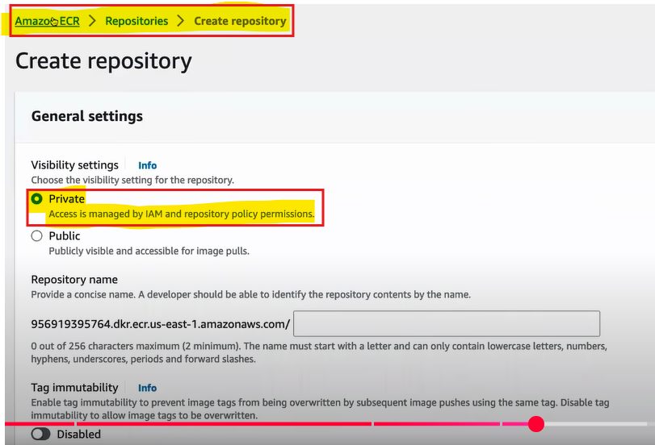

**🡺 First, we need to install AWS CLI for configuration for above command's**

**🡺 docker file**



